Using JBuilder with Tomcat
Web Development is a feature of JBuilder Developer and JBuilder Enterprise
Both Java servlets and JavaServer Pages (JSP) run inside web servers. Tomcat, the JavaServer Pages/Java Servlets reference implementation, is included with JBuilder. Although it might differ from your production web server, Tomcat allows you to develop and test your servlets and JSPs within the JBuilder development environment. This chapter explains how to work with Tomcat running inside JBuilder.
When you install JBuilder Enterprise, three versions of Tomcat, 3.3, 4.0 and 4.1, are automatically installed in your JBuilder directory. By default, they are automatically configured. You can examine the configuration with the Configure Servers dialog box.
Tomcat 4.0 and 4.1 are the JDK 1.4 Lightweight Editions. These editions do not contain an XML parser (JDK 1.4 has one built in) and a few other publicly available components. You can download the full edition from http://jakarta.apache.org/ and use the Configure Servers dialog box to point to them.
Note: In JBuilder Enterprise, Tomcat 4.0 is the default server. To change the default for your project, see "Setting up servers in JBuilder."
To view Tomcat configurations,
- Choose Tools|Configure Servers. The Configure Servers dialog box is displayed.
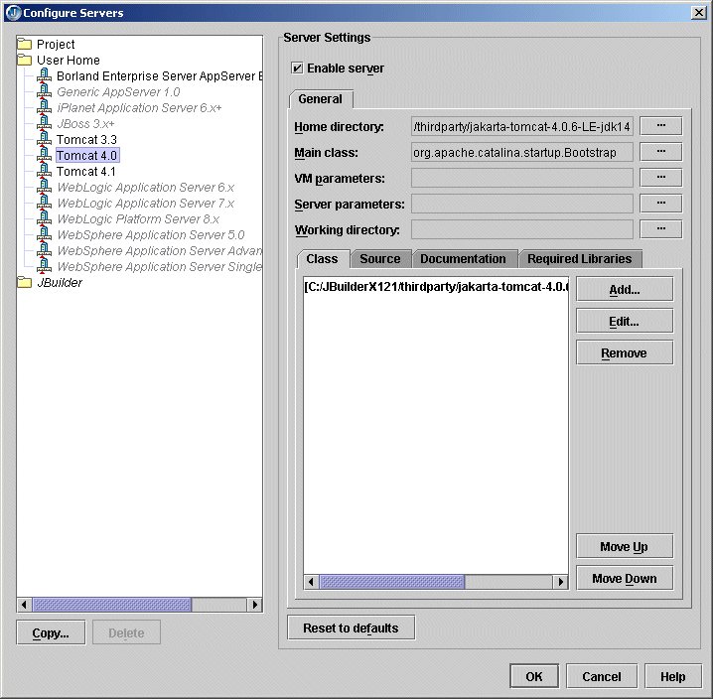
Note: In the tree on the left side of the dialog box, entries in gray have not yet been configured. Entries in red are invalid.
- Choose one of the Tomcat installations from the User Home folder. The Enable Server option at the top of the right side of the dialog box is automatically checked. You do not need to change any settings.
- Click OK to close the dialog box.
If you have installed Tomcat to another directory, and want to run Tomcat from that directory instead of the default, you can change the settings to point to that directory. The following table explains the settings.
Configure Server dialog box settings for Tomcat
Option | Description
Home directory | Tomcat's home directory. If you're reconfiguring one of the Tomcat versions installed with JBuilder, this will be in the <jbuilder>/thirdparty directory.
Main class | The main class for starting the Tomcat web server.
VM parameters | The parameters to pass to the Java VM running the web server.
Server parameters | The parameters to pass to the web server.
Working directory | The working directory.
Class | The location of Tomcat class files.
Source | The location of Tomcat source files.
Documentation | The location of Tomcat documentation files.
Required Libraries | The libraries that Tomcat requires.
If you'd like more information about Tomcat or would like to run it stand-alone, refer to the documentation directory of JBuilder's Tomcat installation:
- Tomcat 3.3: <jbuilder>/thirdparty/jakarta-tomcat-3.3.1/doc
- Tomcat 4.0: <jbuilder>/thirdparty/jakarta-tomcat-4.0.6-LE-jdk14/webapps/tomcat-docs
- Tomcat 4.1: <jbuilder>/thirdparty/jakarta-tomcat-4.1.27-LE-jdk14/webapps/tomcat-docs
Important: Tomcat 4.1 does not support JSP debugging.
Note: The Borland Enterprise Server AppServer Edition 5.2.1 uses Tomcat internally for the production web server. If you're using the Borland Enterprise Server, you do not need to configure Tomcat separately.

Selecting Tomcat as your project's web server
Before you begin web development, you should select Tomcat as the web server for your project. To select the Tomcat web server for your project,
- Choose Project|Project Properties.
- Click the Server node. The Server page is displayed.
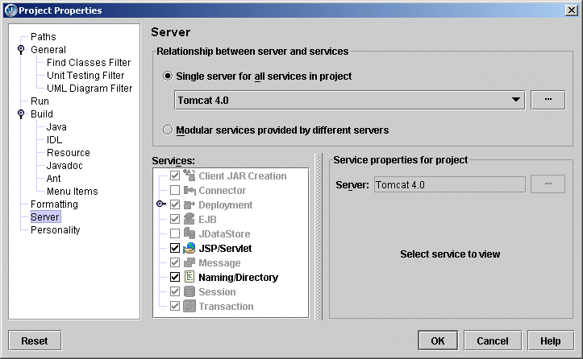
- Select the Single Server For All Services In Project option and select the version of Tomcat you want from the drop-down list.
- If you want to avoid having libraries added to your project that you won't use, uncheck the check box in front of the service(s) you don't need in the Services list. If you disable services, the corresponding JBuilder features will be disabled.
Important: The only service available for Tomcat 3.3 is the JSP/Servlet service. For Tomcat 4.0 and 4.1, the JSP/Servlet and Naming/Directory services are available.
- If you want to make changes to the configuration settings for the selected version of Tomcat, click the ellipsis button to the right of the server name and edit the settings you want on the General and/or Custom pages. Click OK when you're finished.

Running your servlet or JSP with Tomcat
Before you run your web application, you should configure web view options to select how Tomcat is launched in the IDE. For more information, see "Configuring the IDE for web run/debug" in the "Working with web applications in the JBuilder IDE" chapter of the Web Applications Developers Guide.
Before you web run your servlet or JSP in JBuilder, you also need to create a runtime configuration, set run properties for your project, and compile your servlet or JSP. For complete information about these topics, see "Working with web applications in the JBuilder IDE " in the Web Application Developer's Guide. Once you've completed these tasks, you are ready to run your servlet or JSP.
To web run your servlet or JSP in JBuilder, right-click the servlet or JSP file in the project pane and choose Web Run. The Web Run command runs your configuration in Tomcat without debugging it. If your servlet runs from an HTML or SHTML file, right-click that file and choose Web Run.
If the Web Run or Web Debug command is grayed out on the context menu for a servlet or JSP, check the runtime configuration. To run a web application, you need to create a runtime configuration with the server type selected as the current runner. That server must support the JSP/Servlet service. To create a runtime configuration, see "Creating a runtime configuration" in the "Working with web applications in the JBuilder IDE" chapter of the Web Applications developers Guide.
Note: Applets cannot be web run or web debugged. This is because applets don't have a URL or a web context to run in. Additionally, applets run in a client browser as opposed to a server. Typically, you run an applet in Sun's AppletViewer or in JBuilder's AppletTestbed. For more information, see "JBuilder's AppletTestbed and Sun's appletviewer" in the "Working with applets" chapter.

Starting Tomcat
When you choose Web Run, JBuilder starts Tomcat, using:
- The runtime configuration
- The options set on Tools|Preferences|Web
Messages are logged to the web server tab displayed in the message pane at the bottom of the AppBrowser. HTTP commands and parameter values are also echoed to this pane. The name of the tab will reflect the name of the web server, for example "Tomcat" for the Tomcat web server.

Stopping Tomcat
To stop Tomcat, click the Reset Program button on the web server tab. To start the web server again and re-run your web application, click the Restart Program button on the tab. You'll usually follow these steps when you make changes to source code, re-compile, and re-run. You don't need to close the web server pane each time you start the web server.
Note: The first time you press the Reset Program button, it simply sends a command to the server to shutdown. In particular, if you are trying to debug your web application's lifecycle event handlers, this would call the Servlet.destroy() and ServletContextListener.contextDestroyed() methods. If you're not debugging, the server will usually shutdown by itself (Tomcat does this in a few seconds; other server take longer). In any case, if you press the Reset Button a second time, the server process is terminated immediately.

Changing the Tomcat's port number
Occasionally, you may run into a problem where the default port number assigned to your web server (typically 8080) is in use by another application. You can reassign the port number, or simply instruct JBuilder to search for an unused port. (In a typical installation, this is set as the default.) To do this,
- Choose Run|Configurations and select the runtime configuration for your web application. Choose Edit.
- On the Edit Runtime Configuration dialog box, choose the JSP/Servlet Service in the tree on the lower left side of the dialog box.
- In the Port Number field, enter the port number the web server should listen to.
- Choose the Search For Unused Port option to tell JBuilder to choose another port if the specified one is in use. (The port is only searched for the first time a web run is requested.) It is useful to select this option when you are running more than one servlet or JSP, as otherwise you might get a message that the port is busy. It is also useful to check this option in the event that a user problem brings the web server down. With this option selected, you will be protected if the web server is not shut down properly. This option works in conjunction with the Web View options on the Web node of the Preferences dialog box when the specified port is in use by a non-web process.

Creating a custom server.xml file with Tomcat
Typically, when you run your web application using Tomcat in the JBuilder IDE, JBuilder creates a serverXXXX.xml file (where XXXX is the port number Tomcat is listening to) and deletes it when you shut down Tomcat. You can edit the file and force JBuilder to keep it by following these steps:
- Run your web application in JBuilder as you normally would.
- While Tomcat is running, go to your project's Tomcat\conf directory. This folder is created by JBuilder when your web application is running.
- Make a copy of the conf directory in a temp directory.
- Open serverXXXX.xml in the conf directory in a text editor.
- Remove the second line of the file:

- <!--This comment marks this file as generated, so it may be deleted and
- regenerated at any time. To preserve manual changes to this file, delete
- this comment.-->
With this line removed, JBuilder will not automatically delete the file when you stop the server.
- Make other changes to the server configuration file as needed.
- Go back to JBuilder and shut down Tomcat.
- Save the edited file to the copy of the conf directory.
- Copy the conf directory back to your project's Tomcat directory.
- Restart the web server and your web application.
Now, when you re-start the web application and the web server, your edited serverXXXX.xml file will be used instead of an auto-generated one.

Debugging JSPs with Tomcat 4.1
Tomcat 4.1 does not support JSP debugging. You can remedy this problem with the following steps:
- Browse to the <jbuilder>/thirdparty/jakarta-tomcat-4.0.6-LE-jdk14/lib directory.
- Copy jasper-compiler.jar and jasper-runtime.jar to the<jbuilder>/thirdparty/jakarta-tomcat-4.1.27-LE-jdk14/common/lib directory.

